Dear Product Manager and All Stakeholders,

I have analyzed the data from our current RMA report. Per the product manager's request, I have compiled the return data by state and the percentage of returns by product type. The findings can be seen in Figure 1 below. The state with the most returns is Massachusetts with 972 returns and South Carolina with the lowest returns coming in at 702 returns. The results for the percentage of returns by product type are as follows. The product with SKU # BAS-48-1 C has the highest return percentage with 22% returned. SKU # BAS-24-1 C has the lowest return percentage with 0.08% returned. The complete report can be found in Figure 2 below.

This data provides the product manager with good return data by state, which allows you to see which state produces the most returns. This data also shows your percentage of produce being returned. This can show that there is a potential issue with the product. Some potential flaws with this data are we don’t have the reasons for why these products were returned. Having this information can narrow down the reason for the returns and help lower the return percentage. Some limitations of my conclusions are that we don’t have an exact date for the returns, so we don’t know if the returns are over the life of the company or due to a certain revision of the product.

Best Regards,

Brian Blackman

**Fig. 1:** Total Returns by state.

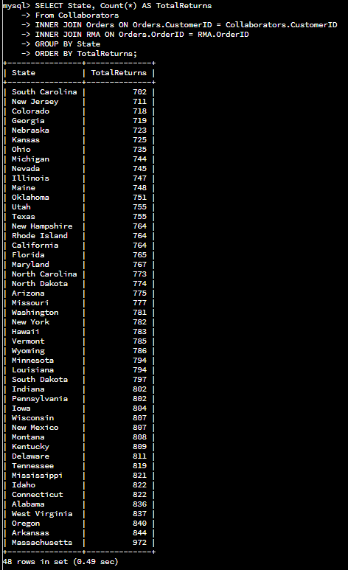

**Fig 2:** Percentage of returns by product type.

